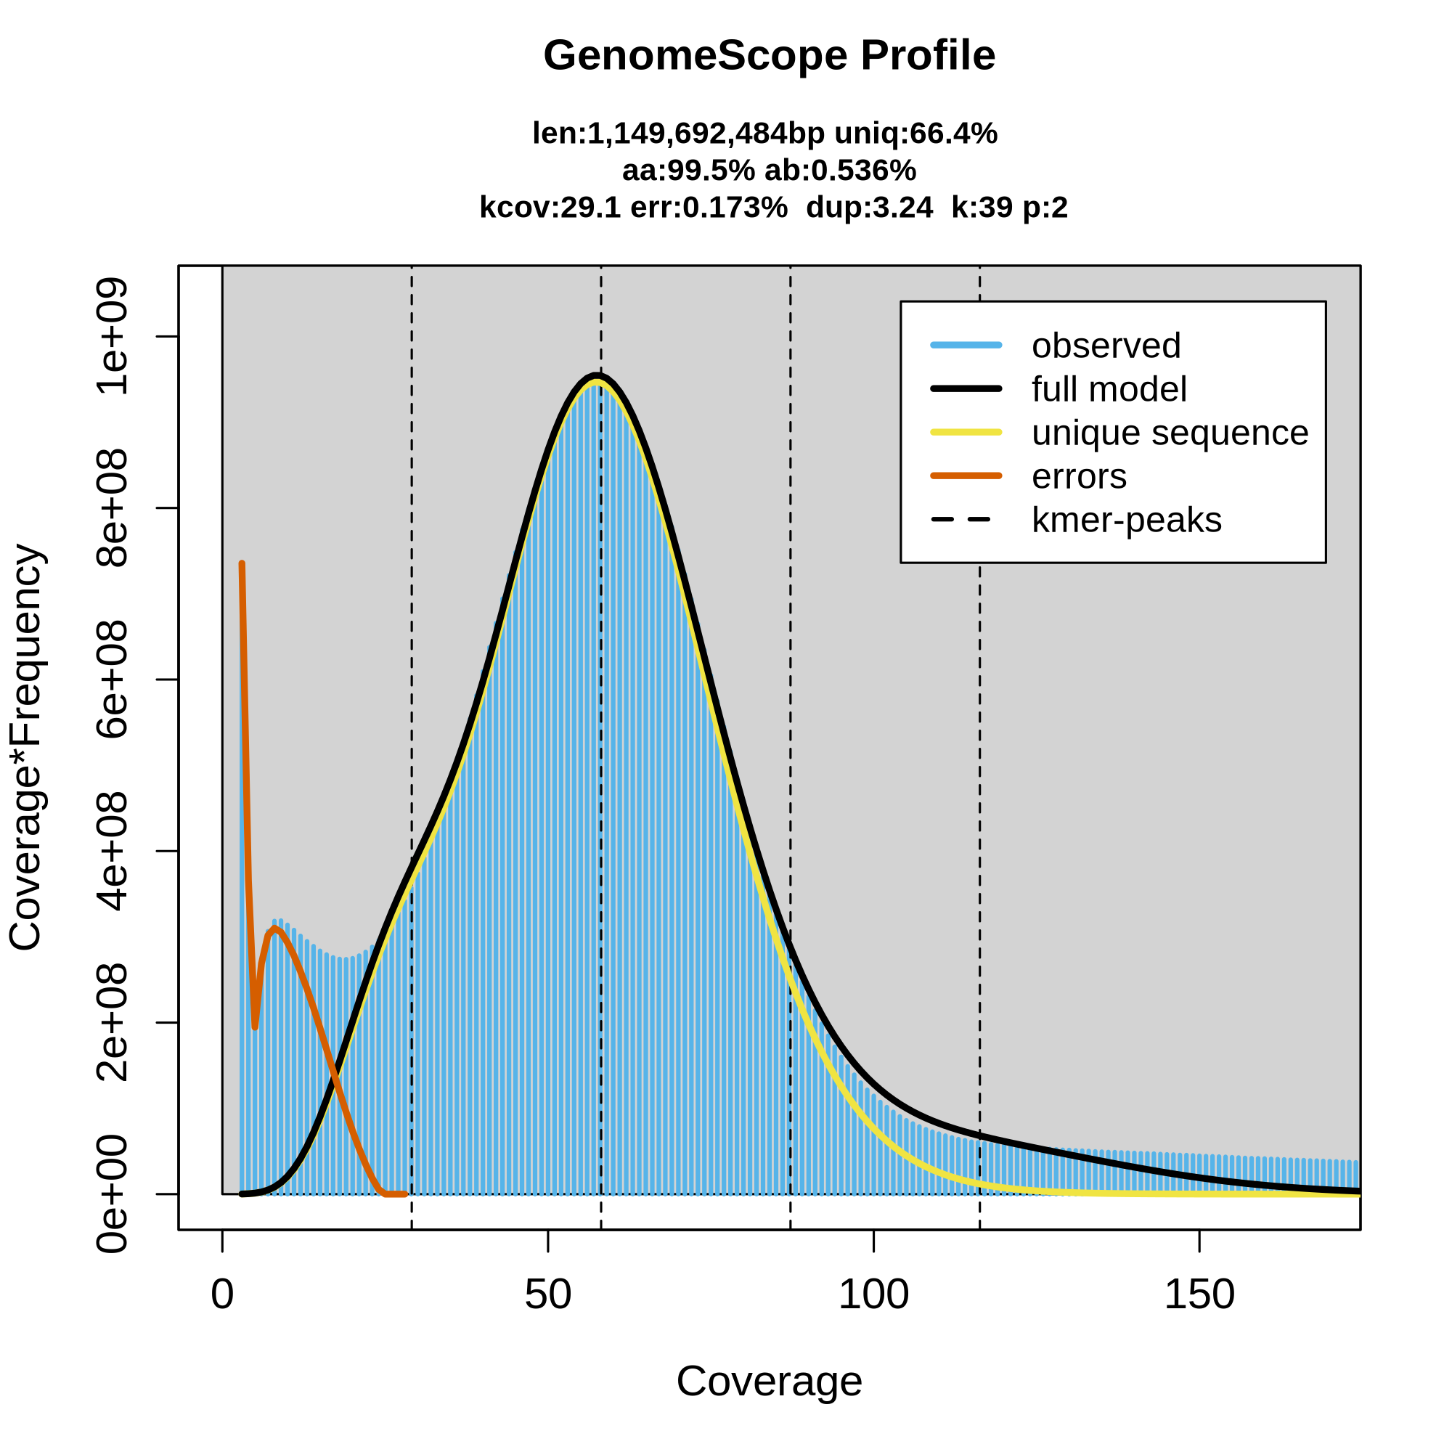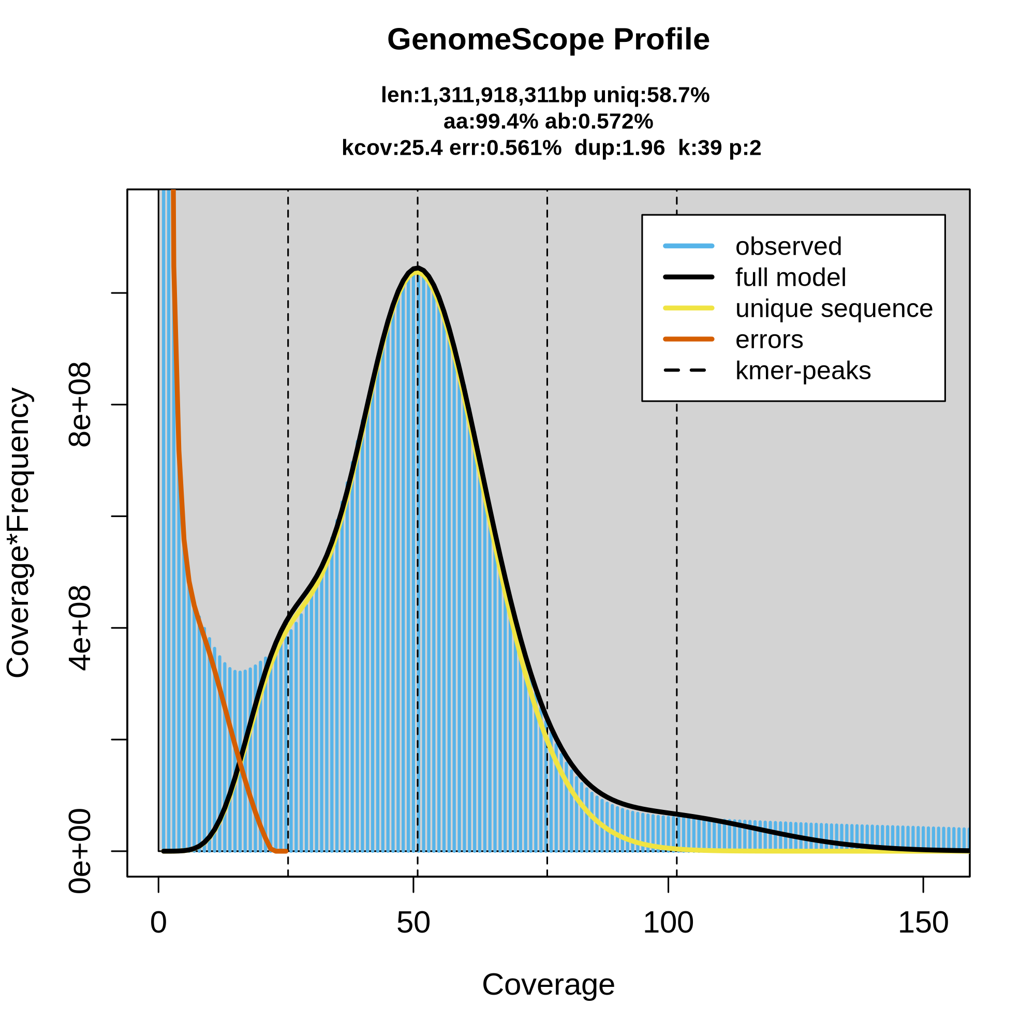
Figure S1. GenomeScope Profile with k-mer=39.
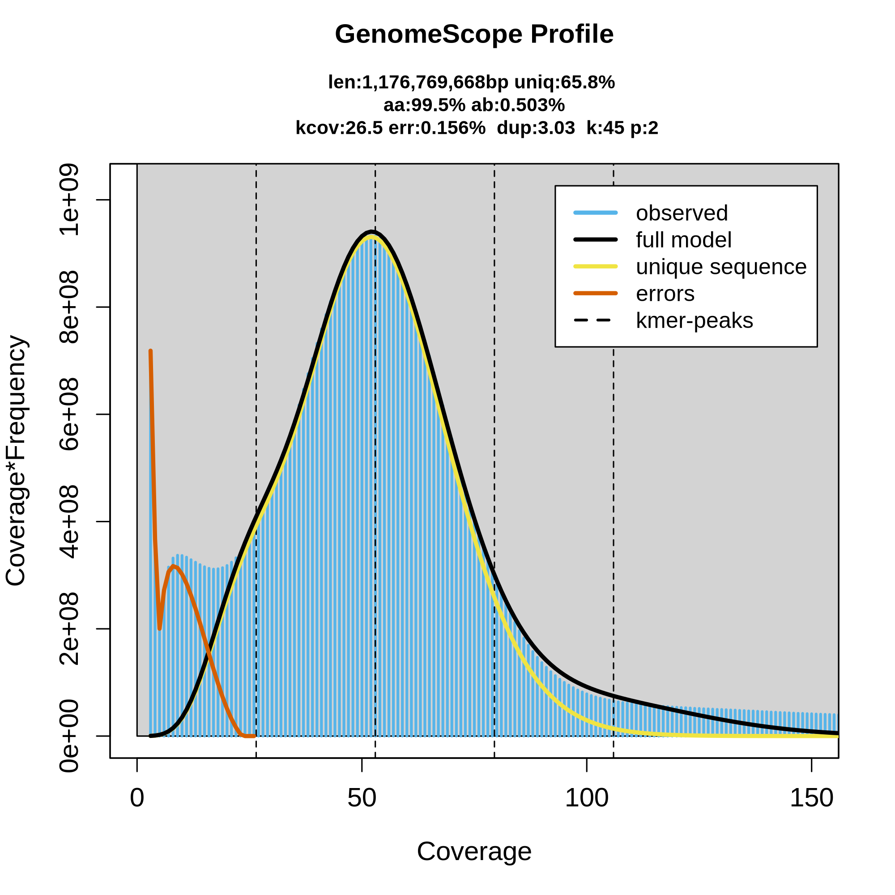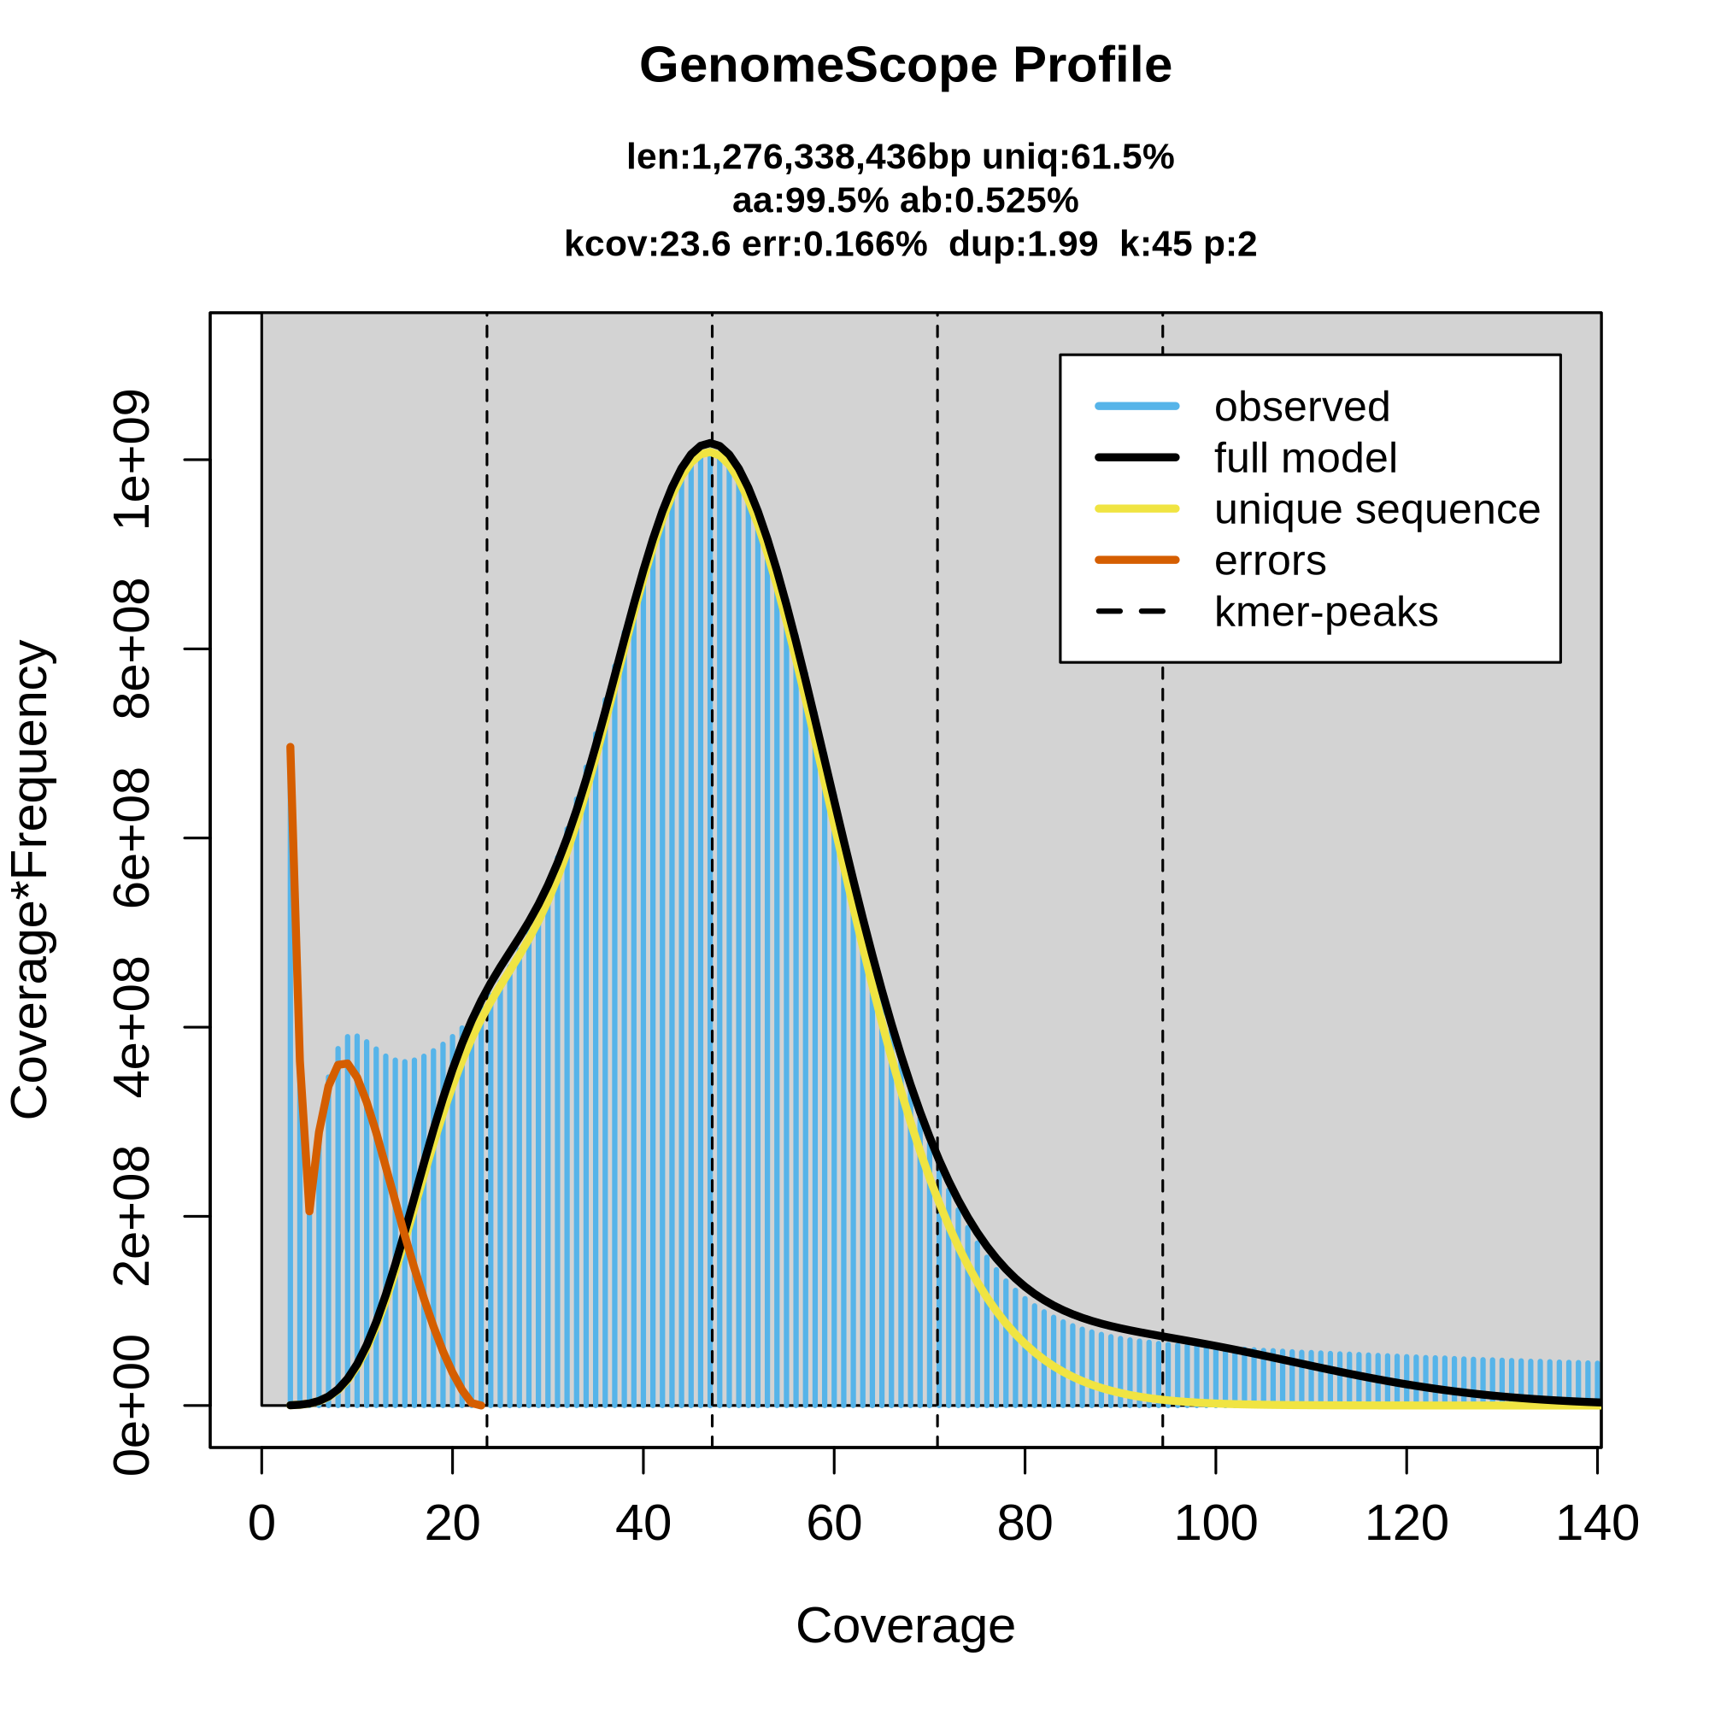
Figure S2. GenomeScope Profile with k-mer=45.

Table S1. Statistical analysis of gene structure annotation of the T. australiensis genome

GeneSet | Number genes | Average exons/gene | Average gene length (bp) | Average transcript length (bp) | Average CDS length (bp) | Average exon length (bp) | Average intron length (bp)
AUGUSTUS | 93,104 | 2.48 | 2435 | 2868 | 1124 | 493 | 1176
PASA | 28,619 | 1.20 | 4469 | 5714 | - | 420 | 1459
EVM | 83,273 | 2.27 | 2513 | 2513 | 1108 | 487 | 1105
PASA-updated | 83,202 | 2.55 | 2724 | 3093 | 1129 | 519 | 1208

Table S2. BUSCOs assessment of genome with predicted gene completeness
Type | Number | Proportion (%)
Complete BUSCOs (C) | 1,455 | 87.3
Complete and single-copy BUSCOs (S) | 1,288 | 77.3
Complete and duplicate-copy BUSCOs (D) | 167 | 10.0
Fragmented BUSCOs (F) | 141 | 8.5
Missing BUSCOs (M) | 71 | 4.3
Total BUSCOs | 1,667 | 100

Table S3. Functional annotation statistics
Database | Number
GO | 16,442
KEGG | 40,746
KOG | 68,297
NR | 78,138
Swiss-Uniprot | 44,429
Pfam | 66,602
InterPro | 73,603
All annotated genes | 81,982
All predicted genes | 85,335

